**Unit 5: Portfolio Website Design**

**Step 1: Define Audience / Tone**

* Who will visit your site? Potential employers? New clients or customers?

Potential employers and customers

* What can make you and/or your product stand out against your competitors?

The individuality of work will set me apart along with a clear and well balance website design.

* How would you speak to your clientele if you were communicating in person? How could you translate that style and tone digitally?

A clean and simple website to convey a professional and organized tone, with the main focal point being each piece of artwork.

* What colors represent you or your product?

Warm colored background that will seem inviting to visitors of the site and focus the eye upon the more involved images of artwork (i.e. terra cotta, yellow, orange, pale pinks, black/white)

* What images illustrate your message?

Gaby's Hard Drive:Users:gabriellefiorenza:Desktop:Screen Shot 2015-01-14 at 4.38.13 PM.png

 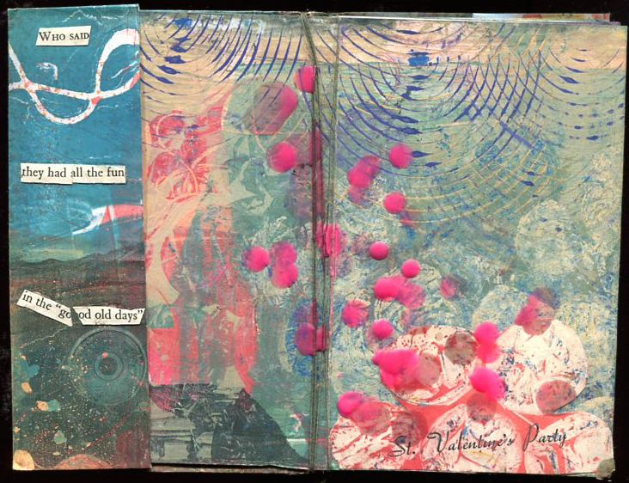**Step 2: Define Site Structure**

What are the three-to-five pages titled?

(Homepage), About, Portfolio and Contact

What will be the purpose for each?

What should each page contain? Will there be textual content? Or just images?

**Homepage**

*Showcasing slideshow of work and draws audience into pages*

Contains:

* Title
* Navigation
* Slideshow of images
* Varying Text (quotes, upcoming events, current info)
* Links at bottom to Twitter, Flickr, Instagram

**Portfolio**

*Showcase the design and development portfolio*

Contains:

* Title
* Navigation
* Varying sizes of art, larger sized slideshow as focal point
* Images of varying size will all be clickable – upon clicking image each will expand to a full screen with small text at bottom containing the following:
  + Image
  + Title, Date created
  + Description
* Links at bottom to Twitter, Flickr, Instagram

**About**

*About myself and style*

* Title
* Navigation
* Paragraph
* Self-portrait (photograph)
* Links at bottom to Twitter, Flickr, Instagram

**Contact**

*Contact information*

* Title
* Navigation
* Slideshow of varying works
* Body text (simple lines of contact info)
* Links at bottom to Twitter, Flickr, Instagram